Contents
1. Introduction 2
2. Staffing of Veterinary Laboratory, Birendranagar, Surkhet 2
3. Laboratory Services 3
3.1 Pathology section 3
3.1.1 Parasitological examination 3
3.1.2 Blood Parasite Examination 4
3.1.3 PM examination 4
3.1.5 Clinico-Hematological Test 6
3.2 Microbiological examination 6
3.2.1 Bacteria isolation 6
3.2.2 California Mastitis Test Result 6
3.2.3 Campylobacter AMR Active Surveillance of poultry 7
3.3 ELISA Report 9
3.5 Rapid test report 10
3.6 AMR Surveillance in Poultry farm 11
4. Epidemic Investigation: 11
5. Staff details 15

1. Introduction
The Veterinary Laboratory (VL) in Surkhet, located in Birendranagar Municipality-7 within the Karnali province, has been a cornerstone of veterinary diagnostics since its establishment in the fiscal year 1988/1989 AD. Initially focused on foundational veterinary services, the lab has since expanded its reach, providing critical diagnostic support across 10 districts in Karnali and six districts in Lumbini province. This extensive coverage is further bolstered by the establishment of basic laboratories in the districts of Banke, Dang, and Jumla. These regional labs conduct essential parasitological examinations, microbiological cultures, and antibiotic sensitivity testing, strengthening the overall diagnostic network to detect and respond to animal health concerns more rapidly and efficiently.
In addition to its diagnostic work, VL Surkhet has become a vital partner for veterinary practitioners and animal health workers by offering technical support, training, and access to advanced diagnostic tools. The laboratory’s comprehensive diagnostic services and preventive efforts exemplify a commitment to veterinary excellence and public health, making it an essential institution within Nepal’s veterinary landscape.

2. Staffing of Veterinary Laboratory, Birendranagar, Surkhet
S.N. | Designation | Class | Number of Post | Fulfilled | Remarks
1 | Senior Veterinary Officer | Gaz.2 | 1 | 1
2 | Veterinary Officer | Gaz.3 | 3 | 3
3 | Animal Health Technician | Non.Gaz.1 | 3 | 3
4 | Asst. Animal Health Technician | Non.Gaz.2 | 2 | 2
5 | Accountant | Non.Gaz.1 | 1 | 1
6 | Kharidar | Non.Gaz.2 | 1 | 1
7 | Driver | Class less | 1 | 1
8 | Office Helper | Class less | 2 | 1 | 2 contract
 | Total |  | 14 | 13

3. Laboratory Services

3.1 Pathology section

3.1.1 Parasitological examination
The Parasitological Unit at the Veterinary Laboratory (VL) in Surkhet plays a crucial role in monitoring and managing parasitic infections in animals by analyzing fecal samples to estimate parasitic burdens. This unit employs several diagnostic methods to detect nematodes, trematodes, and cestodes, which are responsible for various diseases in livestock and poultry. By identifying the specific types and levels of parasitic infections, the unit provides valuable data for effective disease management and prevention strategies.
In a recent assessment, a total of 731 fecal samples were analyzed, out of which 567 samples tested positive for internal parasites, indicating a high prevalence of parasitic infections among the animal population. The primary parasites identified included Fasciola, Coccidia, Haemonchus, Strongylus, Paramphistomum, and Trichuris. Each of these parasites poses significant health risks to animals, potentially impacting their productivity, health, and welfare. By identifying these prevalent parasites, the Parasitological Unit supports veterinarians and animal health workers in targeted treatment efforts and helps inform preventive health practices in the region.
The findings of this fecal examination study are presented in a detailed table, offering a breakdown of the types and frequencies of parasitic infections across the sampled population. This report not only informs regional veterinary practices but also aids in strategic planning for disease control. These insights enable more effective resource allocation for deworming programs, treatment protocols, and preventive measures, ensuring a healthier livestock population and enhancing the overall productivity of the animal industry in the Karnali and Lumbini provinces.
Figure: Fecal examination result of different animal conducted at VL, Surkhet

3.1.2 Blood Parasite Examination
In addition to its parasitological work on fecal samples, the Veterinary Laboratory (VL) in Surkhet also conducts blood parasite examinations to detect blood-borne pathogens that significantly impact livestock health. Out of 649 blood samples analyzed recently, 5 samples tested positive for blood parasites. Among the positive cases, Babesia spp. was identified in 3 samples, affecting 2 cattle and 1 dog. 2 samples were positive for anaplasma. These infections, caused by protozoan parasites transmitted through tick bites, can lead to severe illness and even fatalities in affected animals if left untreated.

3.1.3 PM examination
A total of 608 birds and animals were submitted to the Veterinary Laboratory (VL) in Surkhet for postmortem examination to determine the cause of mortality..
Table: Animal species brought at VL for PM examination

S.N | Species | Total no of sample | PM findings
1 | Broiler | 361 | IBD, Colibacillosis, Mycotoxicity, Ascitis,LPAI
1 | Broiler | 345 | IBD, Colibacillosis, Mycotoxicity, Ascitis
2 | Local | 77 | Salmonellosis, Colibacillosis, IBD, AI (H9)
3 | Parents | 7 | Mycotoxicity
4 | Duck | 8 | Mycotoxicity
5 | Goat | 12 | Pneumonia, Enteritis, Tape worm, PPR
6 | Layers | 54 | Salmonellosis, Colibacillosis, IBD, AI (H9)
7 | Giriraj | 17 | Mycotoxicity
8 | Sheep | 1 | Pneumonia, Poising
9 | Quail | 8 | Mycotoxicity , Colibacillosis
10 | Kaliz | 5 | Mycotoxicity, ND
11 | Dog | 37 | Pneumonia, Enteritis, Rabies
12 | Pig | 12 | Pneumonia, Enteritis, CSF
13 | Turkey | 3 | Colibacillosis, Fowl Pox
14 | Koiler | 12 | Colibacillosis, IBD, Fowl Pox
15 | Cattle | 6 | Rabies, Pneumonia, Food Poising
16 | Buffalo | 4 | Rabies Pneumonia, Food Poising
Total |  | 608

3.1.4 Skin Scraping Test
Among 30 skin scrapings tested at the Veterinary Laboratory (VL) in Surkhet, 10bsamples yielded positive results for various skin infections. Specifically, Sarcoptic mites were identified in 3 goat samples, indicating sarcoptic mange, a common parasitic skin condition that can cause severe itching and skin damage. Additionally, Demodex mites were found in 7 dog samples, often leading to demodectic mange, which can result in hair loss and secondary infections in affected animals. A single case of a fungal infection was detected in a buffalo sample, highlighting the diverse range of dermatological issues faced by different species.

3.1.5 Clinico-Hematological Test
The Hematology Unit at the Veterinary Laboratory (VL) in Surkhet offers comprehensive routine hematological testing for various animals and poultry, aiding in the early detection and management of blood-related disorders and infections. Key hematological parameters measured include Total Erythrocyte Count (TEC), Total Leukocyte Count (TLC), Differential Leukocyte Count (DLC), hemoglobin (Hb) levels, and Packed Cell Volume (PCV). Additionally, the unit performs blood smear staining to identify blood protozoa. In recent assessments, Anaplasma and Babesia species were prevalent among blood samples collected from improved breeds of cattle in the Bardiya and Surkhet districts. A total of 649 samples were processed in the Hematology unit, providing veterinarians with essential diagnostic insights to guide treatment and improve animal health outcomes.

3.2 Microbiological examination
The major samples submitted for the microbiological examinations were milk, water, tissues etc. In a total 403 samples were received at VL for culture and AST.

3.2.1 Bacteria isolation
511 samples were submitted for bacterial culture and identification. Of these, 4101 samples revealed gram-negative bacteria, while 33 samples contained gram-positive bacteria. In the remaining 102 samples, bacterial growth did not occur, potentially due to prior treatment or unsuitable conditions for bacterial proliferation. The primary bacterial isolates included Escherichia coli, Salmonella, Staphylococcus, and Streptococcus species, representing the main pathogens affecting livestock and poultry health.

3.2.2 California Mastitis Test Result
California mastitis test was used to diagnose clinical and sub clinical mastitis of animal in laboratory as well as in field level. Total 66 milk sample were tested. The result of CMT test with their bacteriological finding is given below.
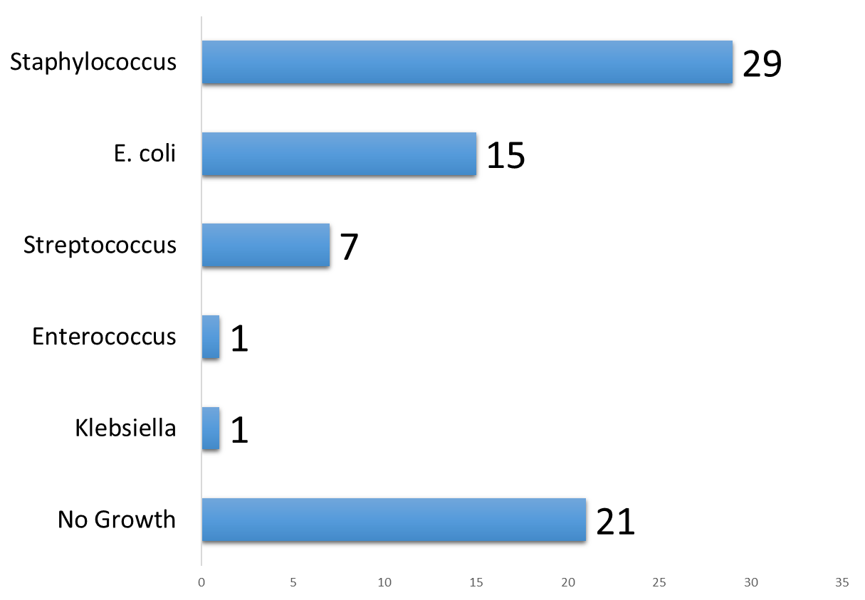

3.2.3 Campylobacter AMR Active Surveillance of poultry
n a study conducted to assess antibiotic resistance patterns in Campylobacter species, 105 cloacal swab samples were collected from various areas of Surkhet and Banke Districts. These samples were tested for susceptibility to commonly used antibiotics, including Ampicillin, Ciprofloxacin, Tetracycline, Azithromycin, Chloramphenicol, and Imipenem. Out of the 105 samples, bacterial growth was observed in 61 samples, while 44 samples showed no bacterial growth.
District | No of sample | Campylobacter isolation
Surkhet | 50 | 17
Banke | 55 | 44
Total | 105 | 61

Resistance pattern
The resistance pattern of the campylobacter organism in different antibiotics is given below.

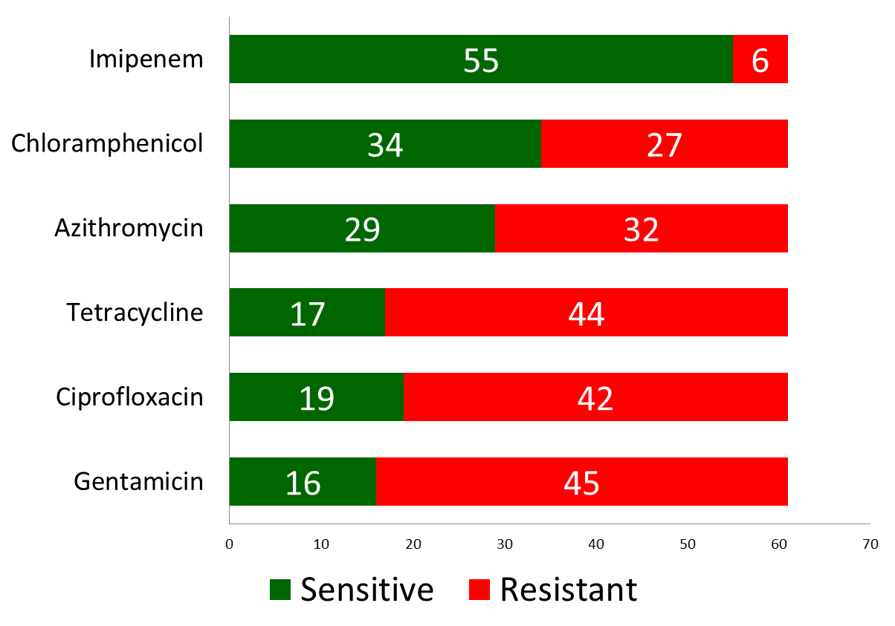

3.2.3 Fish Liver Sample Culture

District | No of Sample | Growth of Gram Positive Bacteria | Growth of Gram Negative Bacteria | No Growth
Bardiya | 28 | 20 | 2 | 6

3.2.4 Culture of water Sample from poultry farm (Surveillance)

District | No of water Sample | Growth of Gram Positive Bacteria | Growth of Gram Negative Bacteria | No Growth
Bardiya | 19 | 0 | 17 | 2
Surkhet | 7 | 0 | 6 | 1
Dailekh | 3 | 2 | 1 | 0
Total | 29 | 2 | 24 | 3

3.3 ELISA Report
Name & Address of farmer | Species | Total no of sample | Sample tested | Test Method | Result |  |  | Remarks
 |  |  |  |  | Pos | Neg | Doubuful | Remarks
Surkhet | Goat | 60 | 60 | Elisa | 13 | 46 | 1 | Toxoplasmosis
Dailekh | Goat | 92 | 92 | Elisa | 5 | 82 | 5 | Capripox
Bardiya | Goat | 92 | 92 | Elisa | 5 | 82 | 5 | Chlamydophilia abortus
Suekhrt | Cattle | 92 | 92 | Elisa | 0 | 92 | 0 | BVD
Surkhet | Goat | 184 | 184 | Elisa | 21 | 0 | 0 | Q Fever
Bardiya | Cattle | 368 | 368 | Elisa | 71 | 297 | 0 | Brucellosis
Bardiya | Cattle | 46 | 46 | Elisa | 34 | 12 | 0 | FMD
Banke | Cattle | 46 | 46 | Elisa | 30 | 16 | 0 | FMD
Jajarkot | Sheep | 44 | 44 | Elisa | 40 | 3 | 1 | PPR
Jumla | Sheep | 92 | 92 | Elisa | 78 | 10 | 2 | PPR
Dang | Goat | 156 | 156 | Elisa | 142 | 12 | 2 | PPR
Dang | Sheep | 28 | 28 | Elisa | 26 | 2 | 0 | PPR
Dailekh | Goat | 184 | 184 | Elisa | 155 | 19 | 6 | PPR
Banke | Goat | 184 | 184 | Elisa | 161 | 20 | 3 | PPR
Surkhet | Goat | 184 | 184 | Elisa | 170 | 8 | 6 | PPR
Total |  | 1852 | 1852 |  | 951 | 701 | 31

3.5 Rapid test report

Species | Sample Tested | Disease
Species | Sample Tested | ND |  | IBD |  | AI |  | IB |  | PPR |  | FMD |  | Brucella |  | Mycoplama |  | Salmonella |  | Rabies |  | Swine fever
Species | Sample Tested | Pos | Neg | Pos | Neg | Pos | Neg | Pos | Neg | Pos | Neg | Pos | Neg | Pos | Neg | Pos | Neg | Pos | Neg | Pos | Neg | Pos | Neg
Goat | 148 | 0 | 0 | 0 | 0 | 0 | 0 | 0 | 0 | 5 | 84 | 0 | 0 | 0 | 48 | 0 | 0 | 0 | 0 | 6 | 5 | 0 | 0
Pig | 11 | 0 | 0 | 0 | 0 | 0 | 0 | 0 | 0 | 0 | 0 | 0 | 0 | 0 | 0 | 0 | 0 | 0 | 0 | 2 | 0 | 2 | 8
Dog | 45 | 0 | 0 | 0 | 0 | 0 | 0 | 0 | 0 | 0 | 0 | 0 | 0 | 0 | 0 | 0 | 0 | 0 | 0 | 28 | 17 | 0 | 0
Cattle | 53 | 0 | 0 | 0 | 0 | 0 | 0 | 0 | 0 | 0 | 0 | 0 | 0 | 0 | 50 | 0 | 0 | 0 | 0 | 2 | 1 | 0 | 0
Buffalo | 5 | 0 | 0 | 0 | 0 | 0 | 0 | 0 | 0 | 0 | 0 | 0 | 0 | 0 | 0 | 0 | 0 | 0 | 0 | 5 | 0 | 0 | 0
Sheep | 9 | 0 | 0 | 0 | 0 | 0 | 0 | 0 | 0 | 0 | 3 | 0 | 0 | 0 | 6 | 0 | 0 | 0 | 0 | 0 | 0 | 0 | 0
Poultry | 1012 | 10 | 188 | 26 | 112 | 7 | 290 | 1 | 15 | 0 | 0 | 0 | 0 | 0 | 0 | 13 | 168 | 15 | 166 | 0 | 0 | 0 | 0
Kaliz | 1 | 1 | 0 | 0 | 0 | 0 | 0 | 0 | 0 | 0 | 0 | 0 | 0 | 0 | 0 | 0 | 0 | 0 | 0 | 0 | 0 | 0 | 0
Chauri | 2 | 0 | 0 | 0 | 0 | 0 | 0 | 0 | 0 | 0 | 0 | 0 | 0 | 0 | 0 | 0 | 0 | 0 | 0 | 2 | 0 | 0 | 0
Total | 1286 | 11 | 188 | 26 | 112 | 7 | 290 | 1 | 15 | 5 | 87 | 0 | 0 | 0 | 104 | 13 | 168 | 15 | 166 | 45 | 23 | 2 | 8

3.6 AMR Surveillance in Poultry farm
Surveillance area : Salyan and Kalikot
Type of Sample: Cloacal swab of Poultry
Isolated bacteria: E. coli | District | No of sample | E. coli isolation
Isolated bacteria: E. coli | Salyan | 58 | 28
Isolated bacteria: E. coli | Kalikot | 41 | 12
Isolated bacteria: E. coli | Total | 99 | 40

4. Epidemic Investigation:
Various disease outbreaks of animal and poultry were investigated during F/Y 2081/82. Whenever request for investigation of an outbreak was received from the district to the VL, a veterinarian or a technician or a team of technicians with necessary sampling kit visited to the site of epidemic, collected epidemiological information and appropriate pathological samples. In the laboratory, pathological samples collected from the field were processed to find out the etiology of the outbreak. Epidemiological information gathered from the site of the outbreak was used to decide the test to be performed in the laboratory and to assist in the confirmation of disease diagnosis. Samples, not possible to process in this laboratory were referred to CVL, Kathmandu.

4.1 Status of Rabies Outbreak
Total no of sample tested | 70
Test Method : | Rapid Test and FAT
Total no of positive case | 52
Percentage of positive case | 74.28%
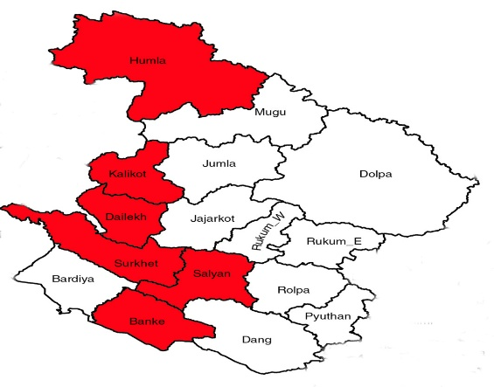

4.2 Status of PPR outbreaks

Species | Total no of sample | Sample tested | Test Method | Result
 |  |  |  | Pos | Neg
Goat | 89 | 89 | Penslide | 5 | 84
Sheep | 46 | 46 | Elisa | 40 | 6
 | 135 | 135 |  | 45 | 90

4.3 Brucella samples report

Species | Total no of sample | Sample tested | Test Method | Result
 |  |  |  | Pos | Neg
Sheep | 6 | 6 | RBPT | 0 | 6
Goat | 48 | 48 | RBPT | 0 | 48
Cattle | 50 | 50 | RBPT | 0 | 50
 | 104 | 104 |  | 0 | 104

4.4 Salmonella samples report

Total no of sample | Sample tested | Test Method | Result
Total no of sample | Sample tested | Test Method | Pos | Neg
151 | 151 | PAT | 9 | 142

4.5 Mycoplasma samples report
Total no of sample | Sample tested | Test Method | Result
Total no of sample | Sample tested | Test Method | Pos | Neg
151 | 151 | PAT | 7 | 144
4.6 BSE Report
Species | Total no of sample | Result
Species | Total no of sample | Pos | Neg
Cattle | 22 |  | 22

4.7 Surveillance of Avian Influenza at Surkhet and Dang

Location | Tracheal swab | Environmental swab | Pig Nasal swab | Total
Dang | 61 | 87 (19) | 14 | 162
Surkhet | 62 | 80 (45) | 11 | 153
Total | 123 | 167 (64) | 25 | 315

5. Staff details
The table below provides a comprehensive list of the staff members at the Veterinary Laboratory, Surkhet, including their designations, contact numbers, and email addresses for correspondence.

S.N | Name of staff | Designation | Phone No. | Email
 | Dr. Arjun Pandit | Senior Veterinary officer | 9845141131 | arjunastha18@gmail.com
 | Dr. Prativa Shrestha | Veterinary Officer | 9841487336 | prativavetdr@gmail.com
 | Dr. Lokendra Neupane | Veterinary Officer | 9845794750 | lokuvet123@gmail.com
 | Bishnu Parsad Dhakal | Veterinary Officer | 9846526551 | bishnu.dhakal37@gmail.com
 | Ratna Lal Pyakurel | Accountant | - | -
 | Shamsher Bd. G.C. | Animal Health Technician | 9848047176 | samsergc772@gmail.com
 | Deviram Kandel | Animal Health Technician | 9858051807 | d.kandel400@gmail.com
 | Manraj Sunar | Animal Health Technician | 9848166730 | -
 | Rama Kumari Bhandari | Assistant Animal Health Technician | 9848041148 | -
 | Chet Kumari Rana | Kharidar | 9848365702 | ranachetana1@gmail.com
 | Mim G.C. Gharti | Assistant Animal Health Technician | 9842368288 | gcmim70@gmail.com
 | Saroj Chaudhary | Light Vehicle Driver | 9842696475 | -
 | Laxmi Kumari Bohara | Office Helper | 9863122994 | -

